Computer Networks (CS303)

Assignment - 7

**U19CS012**

1) Create the below Network, which follows **Static Routing**.

Static routing is a routing type in which a **Network Administrator** configures the routes into the Routing Table **Manually** to be used by the Router to send packets to a destination network.

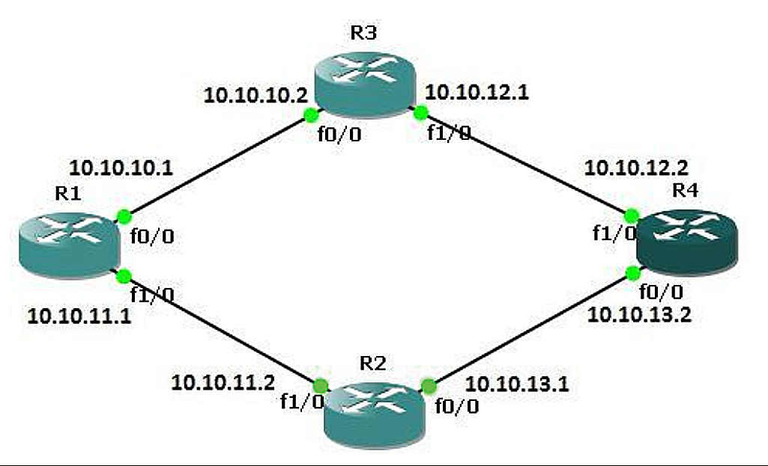

[Correction in Image **f1/0** -> **f0/1**]

Observations from Image

1.) There are **4** Routers with Configuration of

* **f0/0** {Fast Ethernet 0/0} & **f1/0** {Fast Ethernet 0/1}

2.) We can use Router **2811** [Since it has Fast Ethernet Ports]

3.) The Data in the Image can be converted in Tabular Form as Shown Below:

|  |  |  |
| --- | --- | --- |
| Router | Fast Ethernet 0/0 | Fast Ethernet 0/1 |
| R1 | 10.10.10.1 | 10.10.11.1 |
| R2 | 10.10.13.1 | 10.10.11.2 |
| R3 | 10.10.10.2 | 10.10.12.1 |
| R4 | 10.10.13.2 | 10.10.12.2 |

Create the same network in two different ways:

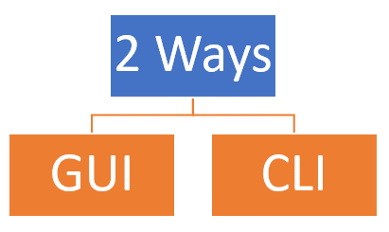

**Configuring IP Address from GUI {Graphical User Interface}**

**Step 1**: In Network Devices > Routers > **Router 2811,** Select 4 Routers and arrange them as shown in Image.

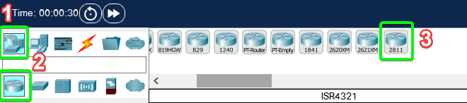

**Step 2**: Connect them Using “Automatically Chosen Connection Type” as shown in image.

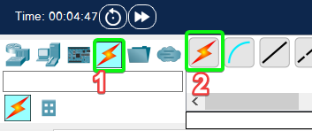

**Step 3**: Configure the IPv4 Address of Router 1 as Shown Below [10 Steps]

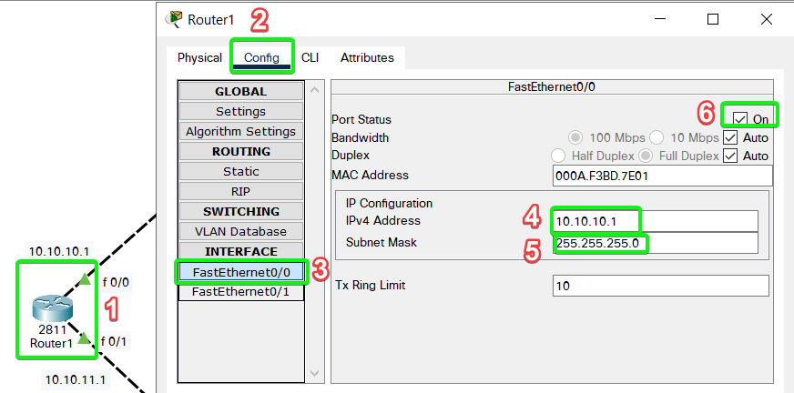

Now, Configure for Fast Ethernet 0/1 as shown below:

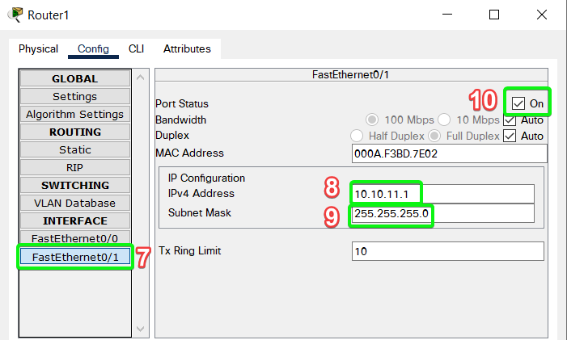

**Step 4**: Repeat Step 3 for Router 2, 3 & 4.

**Step 5**: Label Each Node in the Network as Shown in Image.

Final Network Diagram after Labelling

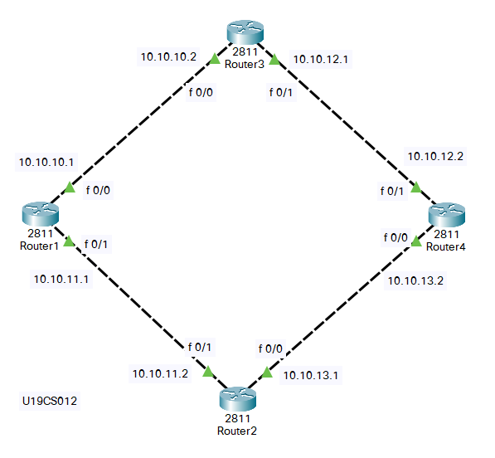

**Command line**

**Step 1**: In Network Devices > Routers > **Router 2811,** Select 4 Routers and arrange them as shown in Image.



**Step 2**: Connect them Using “Automatically Chosen Connection Type” as shown in image.



**Step 3**: Follow the Given below Steps to Configure the Router using CLI.

1.) Press Return [Enter Key]

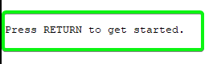

2.) Write "enable" {Router> -> Router#}



3.) Write "configure terminal" {Router# -> Router(config)#}



4.) Write "interface FastEthernet 0/0"



5.) To Configure IP Address of Fast Ethernet 0/0, using CLI,

ip address <IPv4_ADDRESS_HERE> <SUBNET_MASK_HERE>

Eg: ip address 10.10.10.1 255.255.255.0



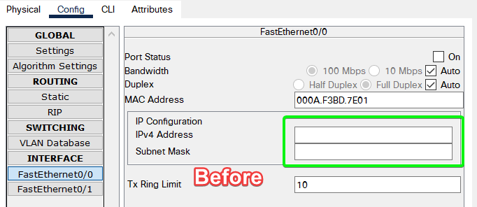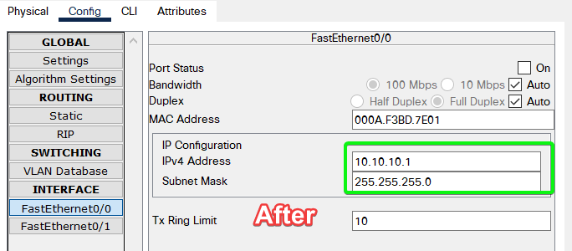

6.) Write "no shutdown" to make the Fast Ethernet 0/0 Port On.

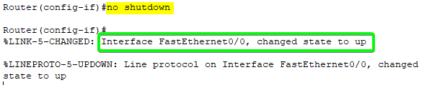

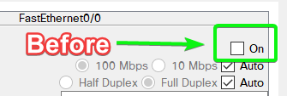 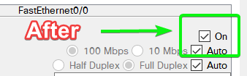

7.) Write "interface FastEthernet 0/1"



8.) To Configure IP Address of Fast Ethernet 0/1, using CLI,

ip address <IPv4_ADDRESS_HERE> <SUBNET_MASK_HERE>

Eg: ip address 10.10.11.1 255.255.255.0



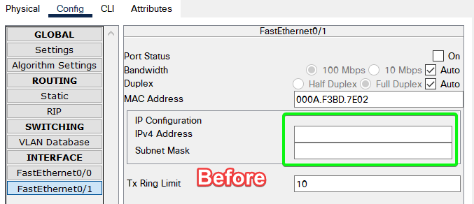 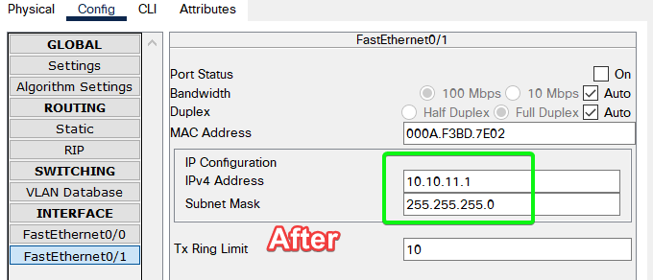

9.) Write "no shutdown" to make the Fast Ethernet 0/1 Port On.

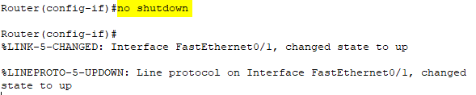

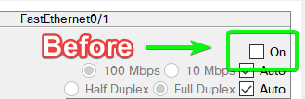 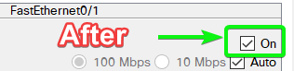

10.) Write "exit" {To Exit from CLI Mode}

**Step 4**: Repeat Step 3 for Router 2, 3 & 4.

Advantages of Static Routing

* It provides **Easy** routing table **Maintenance** in networks.
* Static routing consumes **Less Bandwidth** when compared to dynamic routing as no CPU cycles are-used in route calculation and communication.
* Because static routes do not advertise their route over the network, it results in **better Network Security**.

Dis-Advantages of Static Routing

* In large networks, **configuring and adding** a static route to the routing table is **very difficult**.
* Configuring static routes requires **background knowledge** of the network topology by the network administrator.
* Static route is **error-prone.**

[Reference: <https://www.section.io/engineering-education/understanding-static-dynamic-routing/>]

SUBMITTED BY:

**U19CS012**

BHAGYA VINOD RANA